Assignment (4.4)

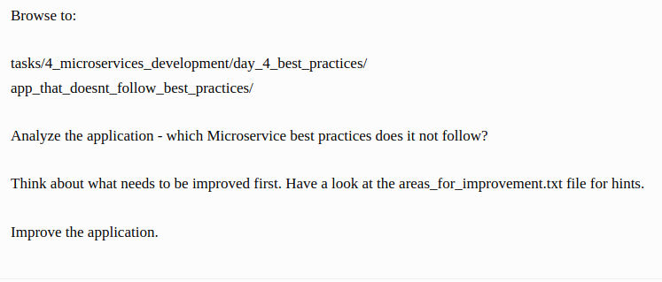
Solution

- Now we can see the logs as output.
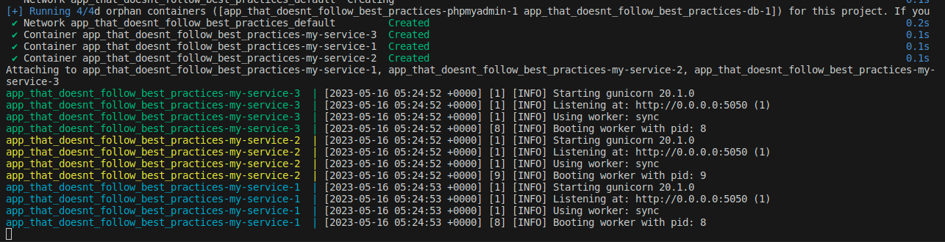

- We also make 3 instance to scale our container.

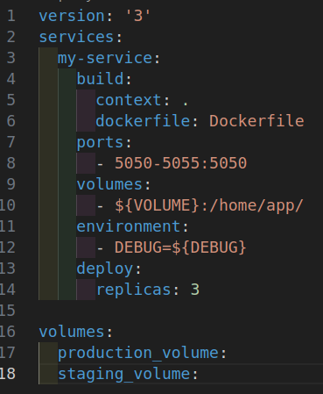

- We also make 2 different volume for staging and production.

- We have assign the 2 different env-files to separate our environment.
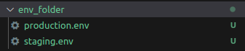

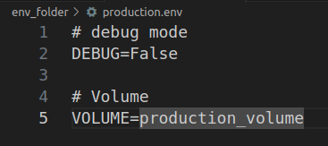

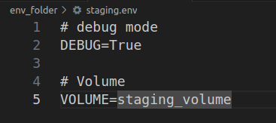

- For the above environment files we use docker compose up command and give parameters.

- docker compose --env-file env_folder/production.env up
- docker compose --env-file env_folder/staging.env up

- We also change requirements installation from run time to build time.
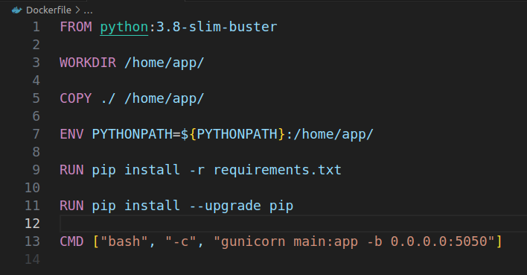

- We also pass debugging form environment file.
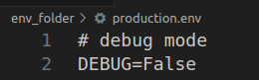

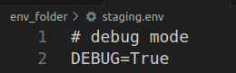

- We also pass volumes from environment files so we can easily replace the database.

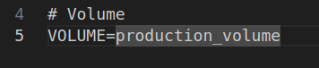

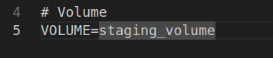

- We also update the main.py file and remove threading, sleep time and show logs in output.

